# Assignment -1

Python Programming

|  |  |  |
| --- | --- | --- |
| Assignment Date | : | 15 October 2022 |
| Student Name | : | Kiruthiga M |
| Student Roll Number | : | 212219040061 |
| Maximum Marks | : | 2 Marks |

# Basic Python

**Question-1:**

Split this string

s = "Hi there Sam!" x = s.split() print(x)

Solution:

['Hi', 'there', 'Sam!']

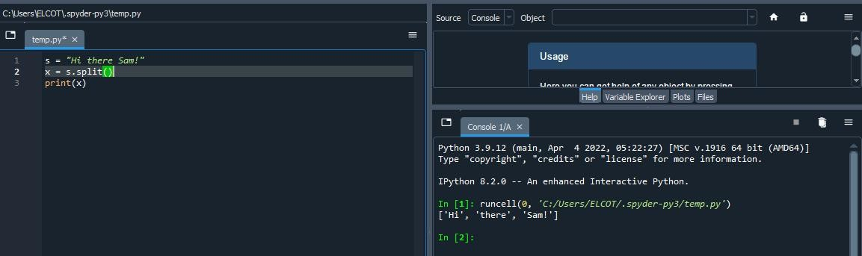Output:

**Question-2:**

## Use .format() to print the following string.

Output should be: The diameter of Earth is 12742 kilometers.

planet = "Earth" diameter = 12742

string = "The diameter of {} is {} kilometers.".format(planet,diameter)

print(string) Solution:

The diameter of Earth is 12742 kilometers.

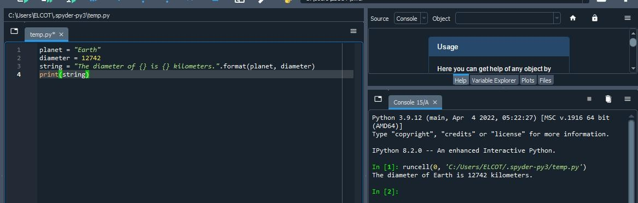Output:

**Question-3:**

## In this nest dictionary grab the word "hello"

d={'k1':[1,2,3,{'tricky':['oh','man','inception',{'target':[1,2, 3'hello']}]}]}

x = d['k1'][3]['tricky'][3]['target'][3] print(x)

Solution:

Hello

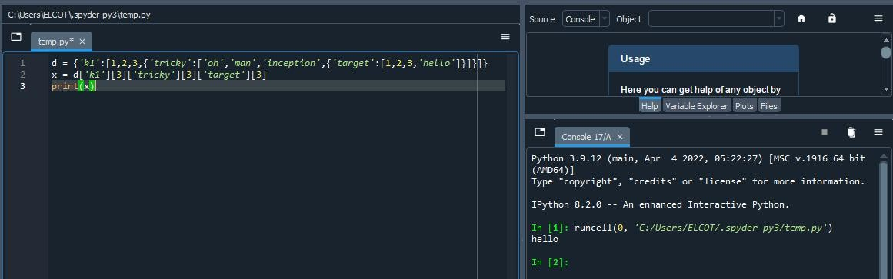Output:

# Numpy

**Question-4:**

import numpy as np

* 1. Create an array of 10 zeros?

import numpy as np

array=np.zeros(10)

print("An array of 10 zeros") print(array)

Solution:

An array of 10 zeros

[0. 0. 0. 0. 0. 0. 0. 0. 0. 0.]

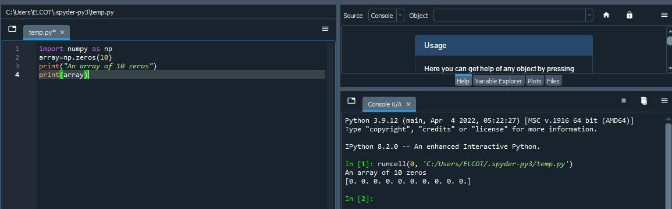Output:

## Create an array of 10 fives?

import numpy as np

Array=np.ones(10)*5

print("An array of 10 fives") print(array)

Solution:

An array of 10 fives

[5. 5. 5. 5. 5. 5. 5. 5. 5. 5.]

Output:

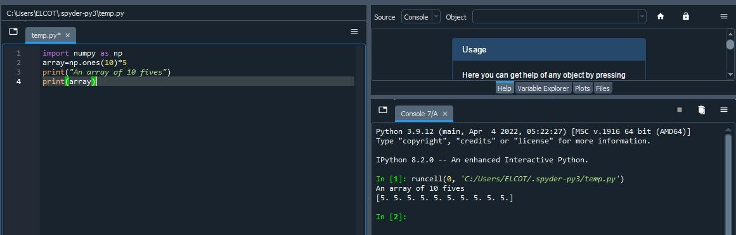

**Question-5:**

## Create an array of all the even integers from 20 to 35

import numpy as np

array=np.arange(20,35,2)

print("An array of all the even integers from 20 to 35") print(array)\

Solution:

An array of all the even integers from 20 to 35 [20 22 24 26 28 30 32 34]

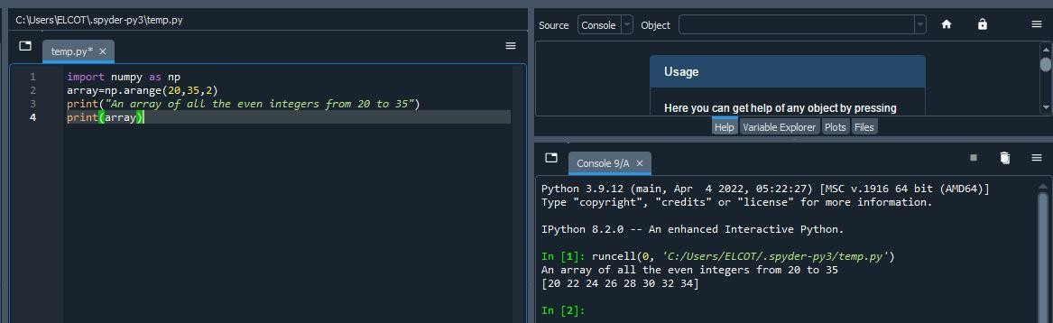Output:

**Question-6:**

## Create a 3x3 matrix with values ranging from

0 to 8

import numpy as np

matrix = np.arange(0, 9).reshape(3,3)

print("A 3X3 matrix with values ranging from 0 to 8\n") print(matrix)

Solution:

A 3X3 matrix with values ranging from 0 to 8 [[0 1 2]

[3 4 5]

[6 7 8]]

Output:

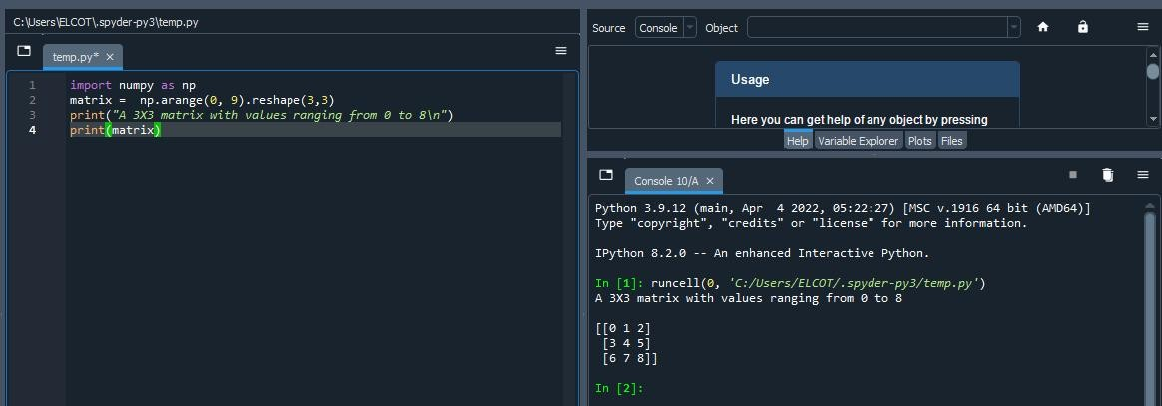

**Question-7:**

## Concatenate a and b

a = np.array([1, 2, 3]),

## b = np.array([4, 5, 6])

import numpy as np

a = np.array([1, 2, 3])

b = np.array([4, 5, 6]) cab=np.concatenate((a,b), axis=None) print("Concatenation of a and b") print(cab)

Solution:

Concatenation of a and b [1 2 3 4 5 6]

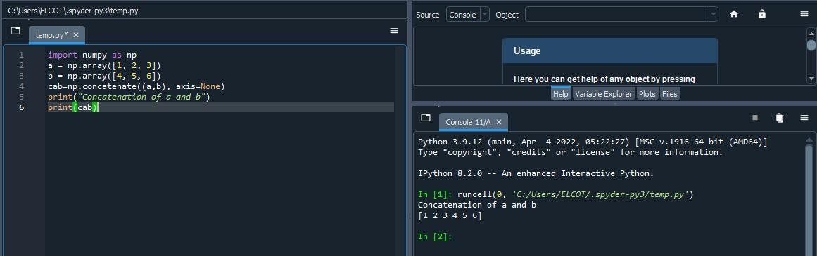Output:

# Pandas

Question-8:

import pandas as pd

Create a dataframe with 3 rows and 2 columns

import pandas as pd

data = {'student_name': ['muthamizhan', 'karthik', 'Ravi'], 'cgpa_marks': [9.4, 8.9, 8.7]}

df = pd.DataFrame(data) df=df.to_string(index=False)

print("A dataframe with 3 rows and 2 columns\n") print (df)

Solution:

A dataframe with 3 rows and 2 columns student_name cgpa_marks

muthamizhan 9.4

karthik 8.9

Ravi 8.7

Output:

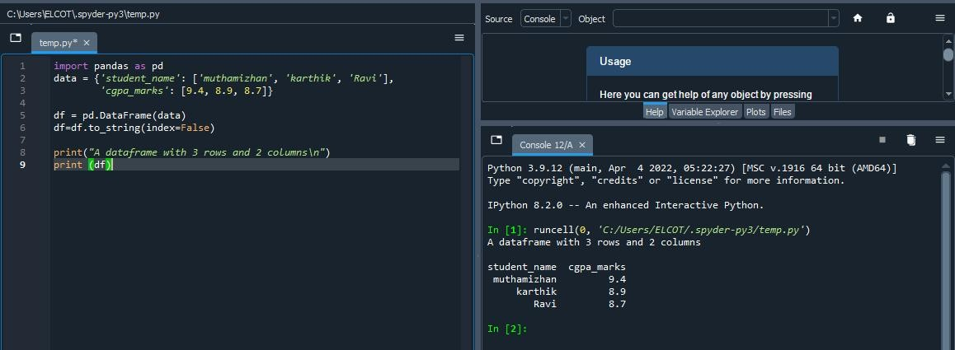

**Question-9**

## Generate the series of dates from 1st Jan, 2023 to 10th Feb, 2023

import pandas as pd

import datetime

start = datetime.datetime.strptime("01-01-2023","%d-%m-

%Y")

date_generated = pd.date_range(start, periods=41) print(date_generated.strftime("%d-%m-%Y")

Solution:

Index(['01-01-2023', '02-01-2023', '03-01-2023', '04-01-2023',

‘05-01-2023','06-01-2023', '07-01-2023', '08-01-2023',

'09-01-23', '10-01-2023','11-01-2023', '12-01-2023',

'13-01-2023', '14-01-2023', '15-01-2023','16-01-2023',

'17-01-2023', '18-01-2023', '19-01-2023', '20-01-2023',

'21-01-2023', '22-01-2023', '23-01-2023', '24-01-2023',

'25-01-2023','26-01-2023', '27-01-2023', '28-01-2023',

'29-01-2023', '30-01-2023','31-01-2023', '01-02-2023',

'02-02-2023', '03-02-2023', '04-02-2023','05-02-2023',

'06-02-2023', '07-02-2023', '08-02-2023', '09-02-2023',

'10-02-2023'],

dtype='object')

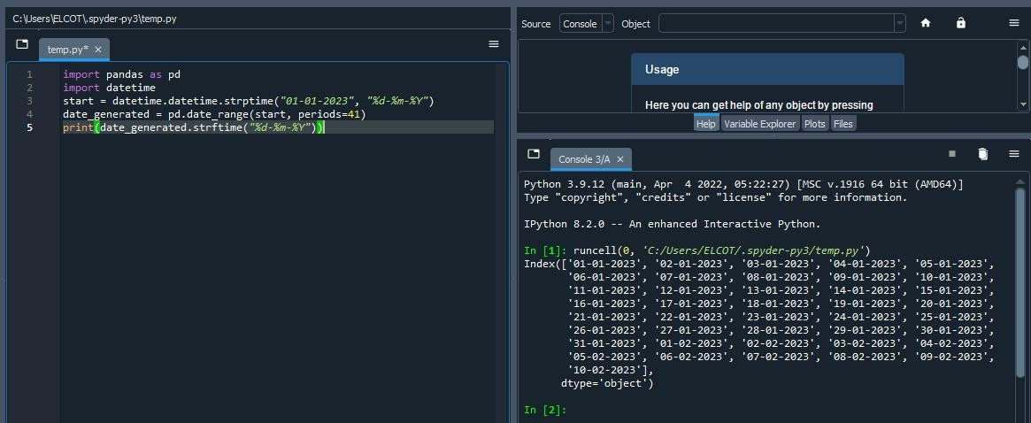Output:

Question-10:

## Create 2D list to DataFrame

import pandas as pd

lists = [[1, 'aaa', 22], [2, 'bbb', 25], [3, 'ccc', 24]]

lists = [[1, 'aaa', 22], [2, 'bbb', 25], [3, 'ccc', 24]] df = pd.DataFrame(lists, columns =['no', 'name', 'd_no']) df=df.to_string(index=False)

print("Given 2D list") print(lists)

print("\n2D list to dataframe") print(df)

Solution:

Given 2D list

[[1, 'aaa', 22], [2, 'bbb', 25], [3, 'ccc', 24]]

|  |  |  |
| --- | --- | --- |
| 2D  no | list  name | to dataframe  d_no |
| 1 | aaa | 22 |
| 2 | bbb | 25 |
| 3 | ccc | 24 |

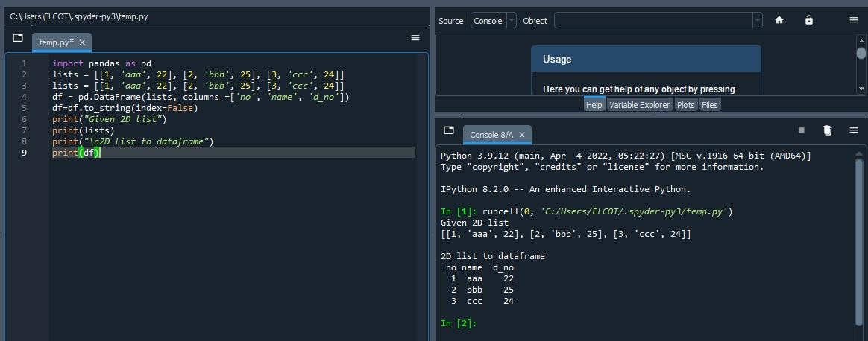Output: